*From The Desk*

**SUMMER 2022 CUMC Crusader**

Christ United Methodist Church···Pastor Ryan Gephart

*of Pastor Ryan……*

**“Speaking Life”**

*“Then God said, “Let us make humankind in our image, in our likeness, so that they may rule over the fish in the sea and the birds in the sky, over the livestock and all the wild animals, and over all the creatures that move along the ground.”*

*So God created humankind in his own image, in the image of God he created them; male and female he created them. (Genesis 1:26-27 NIV)*

The creation story always reminds me of the power of speaking life. God speaks words of light and life and through God’s power, light and life come into being. Animals are spoken into existence. Sky and the waters of the earth are formed as God joyfully speaks them into being. The power of God’s word is not just in the written form (what we consider the Scriptures today), it is also in speaking life. In God’s nature of being loving and good, God joyfully in God’s completeness speaks “wonderful words of life” allowing creation to come into being.

When I sing the hymn, *“Wonderful Words of Life”,* I usually think of the Holy Scriptures. “Sing them over again to me wonderful words of life . . . words of life and beauty teach me faith and duty”, these hymn lyrics immediately place me in the mindset of thinking of what the Gospels record of Jesus’ statements. “Love the Lord your God with all your heart mind, soul and strength and love your neighbor as yourself.” No other words can be said to be more “beautiful words, wonderful words of life” than the great commandment from Jesus.

Yet, one should not just think of words that are written down in the Scriptures as life giving. We should also think of Jesus Christ as the living word. The beginning of the Gospel of John states that Jesus is the Word made flesh. Jesus is the incarnate Son of God whose very nature is to speak life to those with no hope and to conquer death by his resurrection. If Jesus speaks life giving words to the sick and words of power to the disenfranchised, then we are called to follow in his example. We are called to speak life over others. We are called to be great encouragers in times of brokenness. This is not to say we do not mourn with those who mourn, but it is to say that our words have power. They do not have the same power as the words of God, the creator or Jesus Christ the resurrected Lord, but they do have significant power for those who are in our lives.

My friends in Christ, let us speak words of life to others. Let us be encouragers in the word. Let us be on guard for how we critique others and how we offer correction. Offering correction is important, but the way one conveys the message is equally important. Let us speak wonderful words of life to the downtrodden and brokenhearted. Let us convey to others the love of God through Jesus Christ, God’s only Son.

You see the world at this time has its fair share of constant complainers and people who would rather criticize then get in the game of making a difference for Christ. You, my sisters and brothers in Christ, are a wonderful church that knows that we are called to not stay out of the work of God but to go and be Jesus’ disciple by showing love. One significant way we can do this is by speaking words of life and beauty towards others. Kind and compassionate words will help others and ourselves live differently for Jesus Christ. In His name,

Pastor Ryan

**Our Mission:** To make disciples of Jesus Christ for the transformation of the world.

**Our Vision:** Love Jesus, Love like Jesus, and Invite others to Love like Jesus

**Weekday Groups during summer**

**Monday Morning Men** – Will meet on **Mondays** at **9am** in the **Sanctuary.**

**Tuesdays will vary depending on the week and will include Mission Central Days, Shepherding Meetings & Bible Study Outings/Picnics**

**Third & Fourth Thursdays Communions at 11am** at Pennsfield Apartments *(3rd Thursdays)* and Market/High Street Apartments *(4th Thursdays).*

**FALL SMALL GROUPS**

In our church council work along with various contacts with people of the church, we were able to articulate that night time small groups in the fall would be offered again. We are open to as many people who are interested in joining a group. First, we would like to gauge the interest. These groups would meet weekly, bi-weekly or monthly. They could be in multiple formats. Pastor Ryan & other leadership would help convene the groups. We believe that this would be a great way to connect and reconnect with each other. Please respond with your interests, thoughts and questions to Pastor Ryan by email: pryan@christ-umc.net or by cellphone text or call: 570-850-6637.

**2022 CUMC OFFICERS**

**Council Chair:** Jeanette Weaver

**Lay Leader:** Jennifer Rager Kay

**Lay Member:** Sara Dunkelberger

**Trustee Member:** Jinny Harnum

**Trustee Member:** Tony Mowery

**Trustee Member:** Brett Fisher

**Finance Head:** Christopher Bailey

**Secretary to Council:**

Christopher Bailey

**Finance Member:** Dottie Row

**Finance Member:** Pam Wildt

**SPRC Head:** Robyn Rinck

**SPRC Member:** Frank Wetzel

**Our Staff & E-Mail**

**Addresses**

**Pastor Ryan Gephart** [pryan@christ-umc.net](mailto:pryan@christ-umc.net)

**Treasurer Esther Martin** [treasurer@christ-umc.net](mailto:treasurer@christ-umc.net)

**Office Manager Vicki Ewing** [office@christ-umc.net](mailto:office@christ-umc.net)

**Office Assistant Angela Myers**

[office@christ-umc.net](mailto:office@christ-umc.net)

**Custodian Dan Orner**

**Worship Accompanist and**

**Choir Director Marrianne Hoyt** [mw617@aol.com](mailto:mw617@aol.com)

**Children Ministry**

**Amanda Rousu** [children@christ-umc.net](mailto:children@christ-umc.net)

**Agapeland Director**

**Michele Hoch** [agapeland@christ-umc.net](mailto:agapeland@christ-umc.net)

**Teachers**: **Amy Domaracki,**

**Michele Hoch**

**Aides:** **Isabel Marques,**

**Wanda Heimbach,**

**Veronica Hornberger**



Our Mission is to reach out to and empower people affected by limb loss to achieve their full potential through education, support and advocacy, and to promote limb loss prevention.

Whether it’s reaching new amputees with critical recovery information, fighting for fair insurance laws or providing daily tips to make living with limb loss easier, the work of the Amputee Coalition is impacting lives every day. Contact: John J. Werner Jr

570-765-3443

jjwerner@gmail. Com

**THURSDAY NIGHT MEN**

Starting Thursday, September 8, 2022 will be a Men’s group on Thursday nights. We are thinking about meeting starting at 7pm with a format still being worked out. We will meet at the church or at people’s homes. Please let Pastor Ryan know if you are interested in joining the group.

**CHOIR SUMMER BREAK, RESUMPTION DATE & SUMMER SPECIAL MUSIC** –

Choir began its summer break this week and will resume with practice on Wednesday, August 24 @ 6:30pm. If you would like to provide special music this summer, please arrange a Sunday date with Marrianne Hoyt.



**June BIRTHDAYS**

1. Matthew Ferry

03- James Kirchner

1. Tripp Bielskie

04-Landon Rawlings

05-Molly Naugle

06-Chett Arnold

07-Evan Kauffman

07-Chloe Inch

08-Shawn Rawlings

09-Cassie Oelberg

10-Stuart Bielskie

11-John Boggs

11-Amelia Heimbach

11-Drew Gabrielson

13-Carla Ferry

14-Gloria Marlette

21-Anna Gephart

24-Joseph Sanzotto

24-Richard Norman

25-Matthew Rousu

25- MaKayla Mowry

26-Joyce Walshaw

26-Jaime Carpenter

27-Lana Wildt

27-Hunter Kaufman

**July Birthdays**

01-AnnaBella Dagle

02-Megan Troutman

03-Jill Habibi

03-George Hupp

03-Kayleen Long Girton

07-Savanna Snyder

09-Susan Scholl

10-Blanche Gaugler

12-Hannah Reichenbach

14-Jinny Harnum

16-Gary Bunch

16-Ken Reinard

16-Jaxen Gabel

16- Jessica Wenrich

19- Wyman Hoyt

19-Leslie Slaybaugh

21-Michael Kauffman

23-Luca Spriggle

23-Emmaline Spriggle

24-Jaxon Doersam

24-Frank Wetzel

25-Charity Ney

25-Wyatt Steenburg

27-Amy Klick

28-Donna Hoffman

29-Aaron Wink

**august BIRTHDAYS**

1. Linda Leach

02-Jonathan Dunkelberger

03-Hosea Alima

05-Walker Ewing

1. Dawson Mowry

07-Nickolas Artley

08- Ken Estep

09-Judie Charles

09-Joey Sanzotto

10-Mallory Pope

10- Ken Gabrielson

12- Lincoln Trego

15-Jeff Klick

15- Ashlyn Lehman

16- Violet Weaver

20- Pat Bonsall

20- Jordan McGranaghan

21-Katie Klick

21-Joanne Book-Coles

22- Nicole Conrad

23- Robyn Rinck

23-Dawn Ritter

24-Pauline Hoover

24-Sara Dunkelberger

25-Barb Brandt

25-Ken Frederick

26-Amanda Bielskie

28-Benjamin Coles

28-Daniel Coles

29-Allison Rousu

29-Matthew Cooper

31-Riley Bailey

31-Raymond Leach



**June Anniversaries**

05- Ryan & Misty Gephart

06- Nelson & Olga Bailey

11- Keith & Theresa Beaver

16- James & Laurie Kirchner

20- David & Jessica Hummel

20- Larry & Barb Leland

22- Jim & Judie Charles

25- Peter & Jennifer Kay

26- Jim & Robyn Rinck

28- Ron & Jan Boyer

28- Ken & Amber Gabrielson

**July Anniversaries**

03-Michael & Christina Wolfe

04- Matthew & Kanda Gabel

18- Matthew & Amanda Rousu

20- Chris & Carolyn Gemberling

25- Michael & Tara Moyer

27- Hugo & Emilee Alima

28- Jonathan & Crystal Snyder

31- Jeff & Dottie Fasold

**AUGUST Anniversaries**

5 - Nicholas & Laura Manfredini

10 – Pat & Teresa O’Brien

13 – Karl & Carol Wink

19 - Mark & Robin Shearer

**Town halls**

Be on the lookout for town hall small group times with Sara Dunkelberger, Lay Delegate, and Pastor Ryan in late July, August & September 2022.





**Christ UMC, Selinsgrove, PA Youth Group**

The next youth group is June 12, 2022 from 6pm to 7:30pm. We will have pizza, games, Bible lesson and planning discussion at the OWC.

Details for a Hooplas gathering on Sunday, June 26th will be forthcoming.

The youth are hoping to have a Knobels day on Wednesday, July 27th.

Christina Wolfe is organizing a paint party fundraiser for Sept.

Our Youth are attending the following church camps:

Max Ferry: Soaked & Create

Noah Emery: Soaked & Create

Quinn Emery: Soaked

Violet Weaver: Soaked

Andrew Gephart: Soaked

Nate Orner: Messtival

Ryan Mowery: Soaked

Talia Mowery: Soaked

**VACATION COVERAGE FOR PASTORAL EMERGENCIES FROM WEDNESDAY, JUNE 15 TO WEDNESDAY, JUNE 22, 2022** – Pastor Ryan will be on vacation the aforementioned days. For pastoral emergencies from June 15 to June 18 call Pastor Michael Swimley at 570-374-5724 (O) or 570-374-1864 (H). For pastoral emergencies from June 19 to June 22 call Pastor Ruth Liples at 570-374-4400 (O), 570-374-6022 (H), or 717-623-7105 (Cell).



*Select an event based on the grade the camper will complete in Spring of 2022*

**Spark Mini Camp** for Grades 1-4 ~ June 26-29

**Fishing Adventure** for Grades 5-10 ~ June 26 – July 1

**Amp’d** for Grades 7-12 ~ June 26 – July 1

**Camp Splash** for Grades 3-6 ~ July 10-15

**Soaked** for Grades 7-12 ~ July 10-15

**Trailblazers Adventure** for Grades 6-12 ~ July 10-15

**Messtival** for Grades 3-6 ~ July 17-22

**Create!** For Grades 7-12 ~ July 17-22

**Awesome** Elementary for Grades 3-6 ~ July 24-29

**Venture** for Grades 7-12 ~ July 24-29

**Wacky Week** for Grades 2-6 ~ July 31 – August 5

**Ignite** for Grades 7-12 ~ July 31 – August 5

**CHURCH COUNCIL**

Tuesday, June 28th for Visioning Meeting at 6:30pm

Wednesday, July 13th for Business Meeting at 6:30pm

**CARING MINISTRY/**

**EVANGELISM AND HOSPITALITY**

On Sunday, May 15th we had a send-off for Shirley Hoffman. Shirley is moving out of her place at Pennsfield Apartments and moving to be closer to her son. Shirley has served on many committees in the church, she has volunteered in the office, as a counter, as a custodian, on the newsletter crew, in Sunday school, and for Vacation Bible School. She has been the go to person for the Pennsfield Apartments Ministry. I am sure I am leaving out her many ways of serving us. I will just say thank you, Shirley for all you have done for Christ United Methodist Church. May God bless you in your future plans. We love you!



**OUR MORTGAGE**

We borrowed $583,500 and are now paying it back. As of June 9, 2022, we owe $379,817.01. Our monthly payment is $4,765.62 and is funded by the “Imagine Christ” Fund.

**April WORSHIP ATTENDANCE**

Worship 9am 10:30am

|  |  |  |
| --- | --- | --- |
| 3 | 33 | 49 |
| 10 | 55 | 55 |
| 17 | 51 | 53 |
| 24 | 30 | 38 |

**MAY WORSHIP ATTENDANCE**

Worship 9am 10:30am

|  |  |  |
| --- | --- | --- |
| 1 | 50 | 35 |
| 8 | 45 | 35 |
| 15 | 32 | 34 |
| 22 | 36 | 45 |
| 29 | 39 | 38 |

**June Worship Attendance**

Worship 9am 10:30am

|  |  |  |
| --- | --- | --- |
| 5 | 112 | 1 service |
| 12 | 36 | 31 |
| 19 | N/A | N/A |
| 26 | N/A | N/A |

**Easter Sunrise - 36**

**Maundy THursday- 16**

**Good Friday - 19**

**Facebook, YouTube & Sermon By Phone Average Attendance**

**April**

Facebook - 87

YouTube - 8

Sermon By Phone – 2

**May**

Facebook - 90

YouTube - 6

Sermon By Phone – 2

Sermon By Phone #

(570) 213-7375

**9am Worship Outside**

Be on the lookout for some July worship to be Outside at 9am in the OWC. (10:30am worship will remain inside)

Addresses:

**Jinny Harnum**

UPMC Pinnacle Harrisburg

Alex Grass Building Room 577

111 South Front Street

Harrisburg, PA 17101

**Larry Walters**

Manor @ Penn Village

Selinsgrove, PA 17870

**Joyce Walshaw**

Manor @ Penn Village

Selinsgrove, PA 17870



Please keep the family of Dottie Row in prayer. Dottie’s sister Debra Bennett passed away 5/7.

**PENNSFIELD APARTMENTS CONNECTION**

Our next Pennsfield Apartments Connection will be on Thursday, June 23, 2022 at 11am with communion.

**OUR New Confirmed Members**

Ashlyn Olivia Lehman

Adelyn Mae Lehman

Quinn Amelia Emery

Logan James McGranaghan

Nathaniel Thomas Orner

Coy Thomas Arnold

Dylan Michael Levi Wolfe

Talia Marie Mowery

Roman Michael Sanzotto

William Angelo Sanzotto

Violet Ann Weaver



**AGAPELAND**

By Michele Hoch

Agapeland Preschool would like to thank everyone who supported us throughout the school year. We are so proud of our 40 preschool graduates and are excited for those returning in the fall. We are blessed to be a ministry of CUMC and look forward to the upcoming school year.



**SHEPHERDING PROGRAM**

Several different people are working on formalizing ways of connecting with people through shepherding. The first coordinating meeting being held by Dawn Miller and Pastor Ryan will be on Tuesday, June 28, 2022 at 10am in the Adult Sunday School Class Room. We inviting all who are interested from Bible Study groups to evangelism to health/welfare to caregiving to anyone else to come be part of this new venture (that already occurs in formal & informal ways).

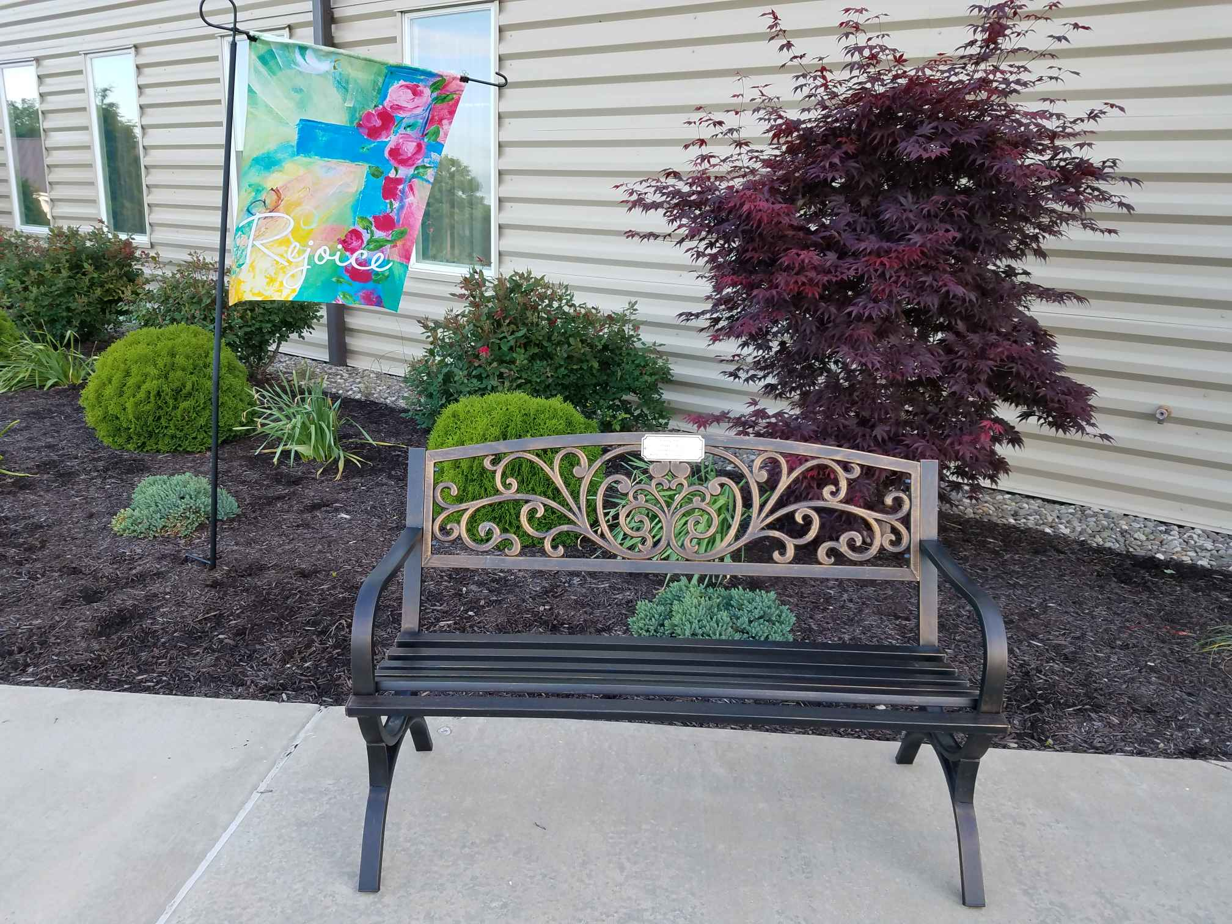 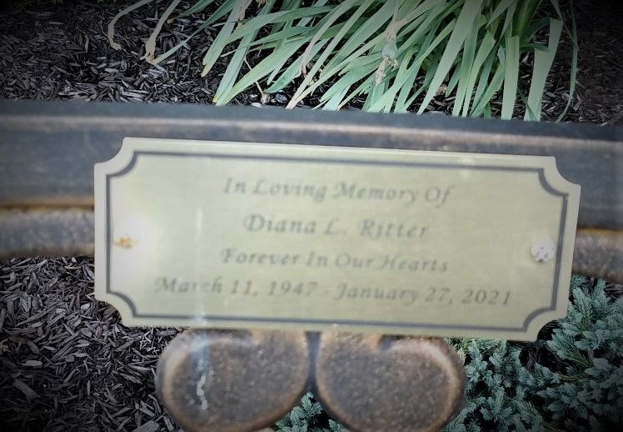

Non Profit Org.

U.S. Postage Paid

Selinsgrove, PA 17870

Permit #13

A special thank you to Steve and Dawn Ritter for the beautiful bench in memory of Diana Ritter.

“In Loving Memory Of

Diana L. Ritter

Forever In Our Hearts

March 11, 1947 – January 27, 2021”

Christ United Methodist Church

145 Disciple Drive · Selinsgrove, PA 17870

Christ UMC

145 Disciple Drive

Selinsgrove, PA 17870

ELECTRONIC

Service Requested

|  |  |  |  |  |  |  |
| --- | --- | --- | --- | --- | --- | --- |
| **Sunday** | **Monday** | **Tuesday** | **Wednesday** | **Thursday** | **Friday** | **Saturday** |
|  | **Office Hours**  Mon, Tues, Wed, & Fri ~ 8am - 3pm  Thurs ~ 8am to 4pm (till July 22nd)  **AC-**Adult Sunday School Class  **MR-** Multipurpose Room/Sanctuary  **OWC-** Outdoor Worship Center  **CF**-Conference Room |  | 1  Pastor @ | 2  Annual------ | 3  Conference-🡪 | 4  **7pm** Online worship |
| 5  Confirmation/  Graduate Recognition  **7am** Online worship  **9:45am** Worship Sanctuary | 6  **9am** Monday Morning Men-breakfast | 7  Mission Central  Day  Speech Team- 12pm – 1:30pm | 8  **9am** Facebook  Live Prayer | 9  Speech Team- 11:15am – 12pm | 10  3:15pm Pastor visiting | 11  **7pm** Online worship |
| 12  **7am** Online worship  **9am** Worship  **10am** Town Hall  **10:30am** Worship Sanctuary  **10am** Town Hall  Youth Event | 13  **9am** Monday Morning Men-MR  Speech Team- 9am – 10:30am | 14  9am Online Bible Study  11am Bible Study  Picnic @ OWC  Speech Team- 12pm – 1:30pm | 15  **9am** Facebook  Live Prayer  Speech Team- 9am – 2:30pm  Pastor-vacation till 6/22 | 16  Speech Team- 8am – 10am | 17 | 18  **7pm** Online worship |
| 19 **Father’s Day**  **Jim & Judie Leading**  **7am** Online worship  **9am** Worship  **10:30am** Worship Sanctuary | 20  **9am** Monday Morning Men-MR | 21 | 22  **9am** Facebook  Live Prayer | 23  **11am** Pennsfield Apts. Connection w/ communion  Pastor Back from vacation | 24 | 25  **7pm** Online  worship |
| 26  **7am** Online worship  **9am** Worship  **10:30am** Worship Sanctuary  Youth Event @ Hooplas | 27  **9am** Monday Morning Men-@ Kidsgrove | 28  **10am** Shepherding  Program Mtg @ AC  **6:30pm** Church  Council Visioning Mtg. - CF | 29  **9am** Facebook  Live Prayer  Pastor Vacation till 7/6 | 30  JUNE  2022 |  |  |

|  |  |  |  |  |  |  |
| --- | --- | --- | --- | --- | --- | --- |
| **Sunday** | **Monday** | **Tuesday** | **Wednesday** | **Thursday** | **Friday** | **Saturday** |
|  | **Office Hours**  Mon, Tues, Wed, & Fri ~ 8am - 3pm  Thurs ~ 8am to 4pm (till July 22nd)  **AC-**Adult Sunday School Class  **MR-** Multipurpose Rm/Sanct.  **CF**- Conference Rm.  **OWC**- Outdoor Worship Center/Pavillion |  | **Multiple Children & Youth are at Church Camp at Wesley Forest in July** |  | 1 | 2  **7pm** Online worship |
| 3  **Special Music Presentation**  **7am** Online worship  **9am** Worship  **10:30am** Worship Sanctuary | 4  OFFICE CLOSED | 5 | 6  **9am** Facebook  Live Prayer | 7  Pastor back from vacation | 8 | 9  11:30am – 3:30pm Tres Dias @ OWC  **7pm** Online worship |
| 10  **7am** Online worship  **9am** Worship  **10:30am** Worship Sanctuary | 11  **9am** Monday Morning Men-MR | 12 | 13  **9am** Facebook  Live Prayer  **6:30pm** Church Council Business Mtg. -CF | 14 | 15  Deadline for Health & Welfare collecting school supplies | 16  **7pm** Online worship |
| 17  **7am** Online worship  **9am** Worship  **10:30am** Worship Sanctuary | 18  **9am** Monday Morning Men-MR | 19 | 20  **9am** Facebook  Live Prayer | 21 | 22 | 23  **7pm** Online worship  OWC Reserved-Private Party |
| 24 Baptism  **7am** Online worship  **9am** Worship  **10:30am** Worship Sanctuary  OWC - reserved | 25  **9am** Monday Morning Men-MR | 26 | 27  **9am** Facebook  Live Prayer  Youth Event at Knobels | 28  OFFICE OPEN IN AFTERNOON | 29  OFFICE CLOSED | 30  **7pm** Online worship |
| 31  **7am** Online worship  **9am** Worship  **10:30am** Worship Sanctuary |  |  |  |  | JULY  2022 |  |

The Outdoor Worship Center wind breaking retractable curtains have been installed in honor of Kathy Showers .

The Outdoor Worship Center wind breaking retractable curtains have been installed in honor of Kathy Showers. In the near future we will have a dedication.

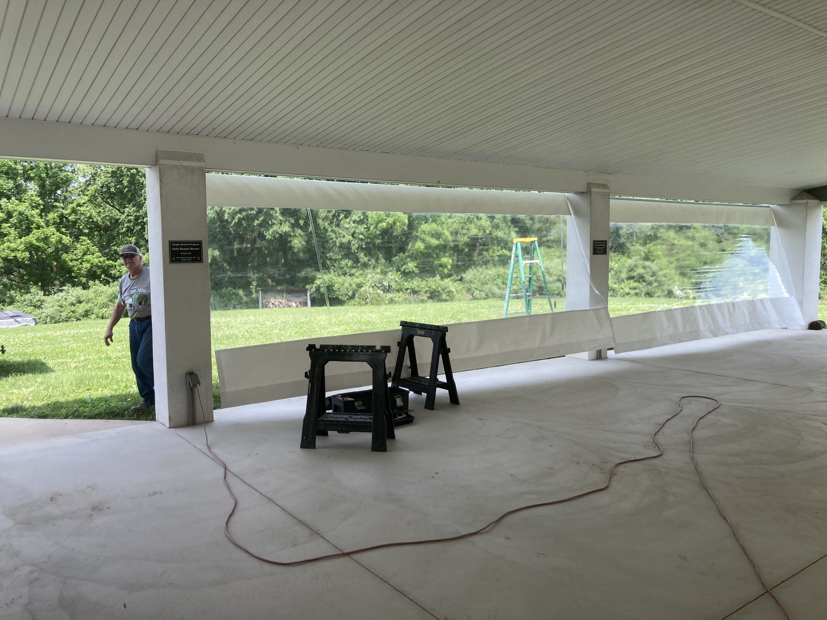 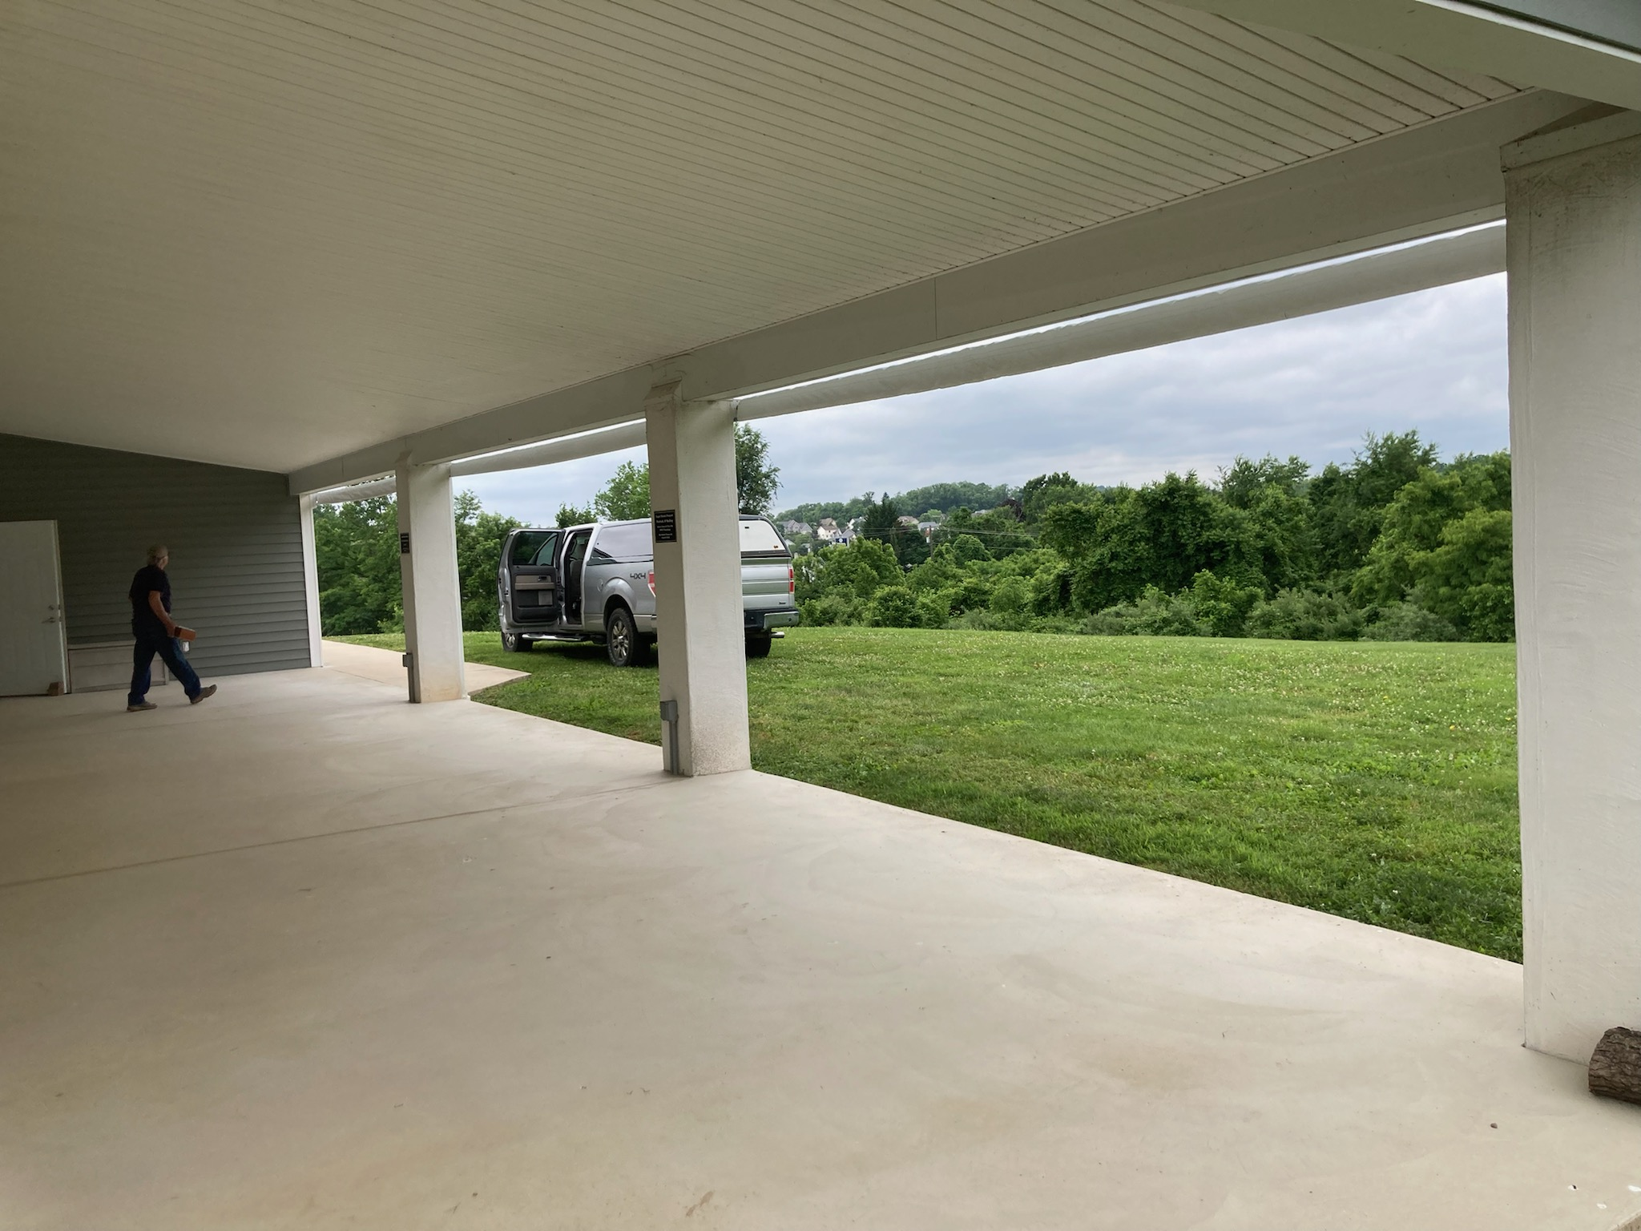

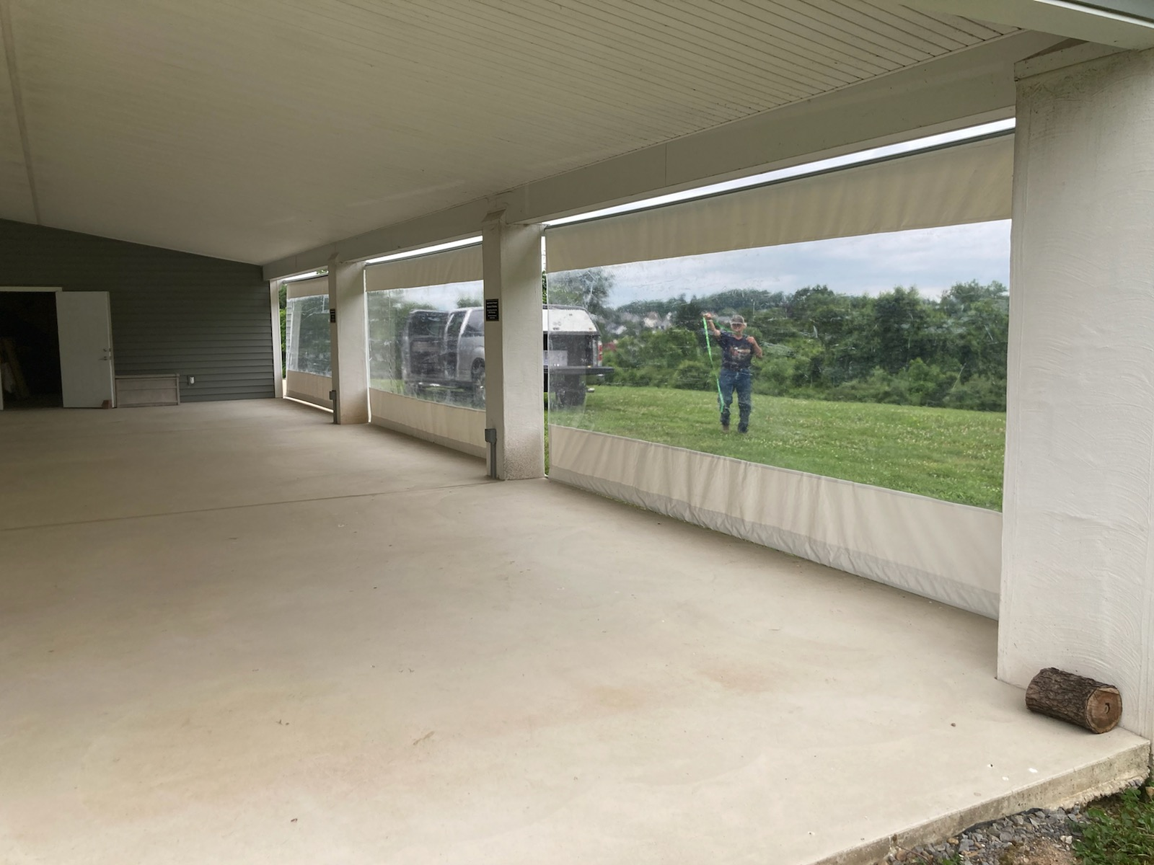 

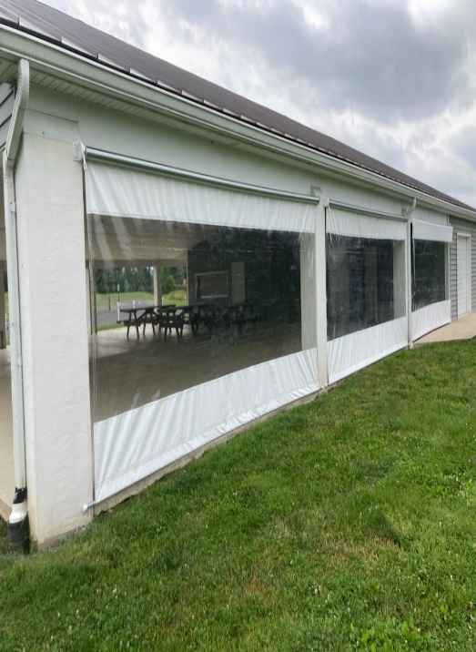

|  |  |  |  |  |  |  |  |  |  |  |  |  |  |  |  |  |  |  |  |  |  |  |  |  |  |  |  |  |  |  |  |  |  |  |  |  |  |  |  |  |  |  |
| --- | --- | --- | --- | --- | --- | --- | --- | --- | --- | --- | --- | --- | --- | --- | --- | --- | --- | --- | --- | --- | --- | --- | --- | --- | --- | --- | --- | --- | --- | --- | --- | --- | --- | --- | --- | --- | --- | --- | --- | --- | --- | --- |
| |  |  |  |  |  |  |  | | --- | --- | --- | --- | --- | --- | --- | | **Sunday** | **Monday** | **Tuesday** | **Wednesday** | **Thursday** | **Friday** | **Saturday** | | **Many August activities with Youth on Sunday nights & Tuesday activities were not scheduled at the time of publishing (August office hours to be determined)** | 1  **9am** Monday Morning Men-MR  Pastor vacation till 8/8 | 2 | 3 | 4 | 5 | 6  **7pm** Online worship | | 7  **7am** Online worship  **9am** Worship  **10:30am** Worship Sanctuary | 8  **9am** Monday Morning Men-MR | 9  Pastor back from vacation | 10  **9am** Facebook  Live Prayer | 11 | 12 | 13  **7pm** Online worship | | 14  **7am** Online worship  **9am** Worship  **10:30am** Worship Sanctuary  After church Children’s Ministry Picnic/Bible School Activities | 15  **9am** Monday Morning Men-MR | 16 | 17  **9am** Facebook  Live Prayer | 18 | 19 | 20  **7pm** Online worship | | 21  **7am** Online worship  **9am** Worship  **10:30am** Worship Sanctuary | 22  **9am** Monday Morning Men-MR | 23 | 24  **9am** Facebook  Live Prayer  6:30pm Choir | 25 | 26 | 27  **7pm** Online worship | | 28  **7am** Online worship  **9am** Worship  **10:30am** Worship Sanctuary | 29  **9am** Monday Morning Men-MR | 30 | 31  **9am** Facebook  Live Prayer  6:30pm Choir | AUGUST 2022  **AC-**Adult Sunday School Class  **MR-** Multipurpose Rm/Sanct.  **CF**- Conference Rm.  **OWC**- Outdoor Worship Center/Pavillion |  |  | |
|  |

|  |
| --- |
| **CHILDREN’S MINISTRY**  The end of May was the last Children’s Sunday School Class for the School Year. We will restart Children’s Sunday school after Labor Day. ***Lay Member to Annual Conference, Sara Dunkelberger, & Pastor Ryan along with other leaders would like to put together a summer family afternoon picnic with all of the families of children & youth to talk about our set-up for next school year as well as have Bible School activity time.***The picnic will be Sunday, August 14, 2022 after church services and include Bible School activity time.  **SUMMER Office hours**  Monday, Tuesday, Wednesday: 8am to 3pm *(Office Closed Monday, July 4)*  Thursday till July 22: 8am to 4pm *(Office open in the afternoon on July 28)*  Friday till July 22 – 8am to 3pm *(Office Closed on July 29)*  There will be changes starting in August as Angela Myers is heading back to school for nursing and finishing her work as Thursday/Friday office assistant on Friday, July 22. We will be reconfiguring Thursday/Friday office hours and finding a better way of communicating. Be on the lookout as Church Council approves these items at its July 13, 2022 meeting.    **FINANCIAL UPDATE**  By the Financial Team Church Council of Chris Bailey, Dottie Row, Pam Wildt & Pastor Ryan    A review of our year to date giving to the General Fund indicates that we are trending slightly below our 2022 budgeted/anticipated levels. To avoid dipping into our current savings, our General Fund giving should average around $17,500 each month. Through May, we have surpassed this budgeted value 1 time, met it 1 time and fell short 3 times. Our average giving to general fund expenses through May is $16,276 per month. Due to good management of spending, we were able to be at breakeven through mid-May but started dipping into reserves by the end of May. Due to inflation, some active givers experiencing medical difficulties, and other factors; we can sense that we will start to dip into reserves more throughout the year. Operating at these levels is not sustainable in the long term and we have taken proactive steps to minimize spending wherever possible, including plans to reduce office staffing and continue to shave expenses in other areas (less time for office assistant, continuing normal hours for office manager). We have also initiated some information gathering regarding the potential for solar power at the church and parsonage.  ***(continued in the next column)***  Knowing that many of us are still feeling the impact of the pandemic and that all of us are feeling the effects of inflation, this situation is understandable.  We also recognize that the upcoming summer months generally means more travel, less frequent church attendance and consequently, less giving.  However, we would humbly ask that if you and your family have the ability to maintain your current level of giving to the General Fund in the upcoming weeks and months, please do so.  Needless to say, any giving above and beyond your normal offering will be used to help address the shortfall that we have been experiencing.  If we, as a church, can see increased giving to the general fund by $500 to $600 a week, we believe a shortfall could be minimized.  This first Sunday of June was excellent in giving and we hope we can continue with this trend.  We are also thankful for continued giving to the Building Fund and other funds which allows us to pay our mortgage and continue to fund special projects.  Additionally, if you would like to sign-up for electronic giving, please pick up a form by the coffee table.  Thank you for all you do and for all the amazing giving in time, talents and treasures that happens at CUMC.  **ADULT SUNDAY SCHOOL**  Marrianne Hoyt & Dottie Row are in discernment about restarting an adult Sunday School class in the fall. More details to come in the future. |
|  |

